Assignment 7:

## Afia Fahmida Rahman

17101240

Q. Find out the COCOMO cost of:

1. USIS (BRACU):
2. COCOMO COST COUNT:
3. Organic mode:

E=2.4(1.6)1.05 = 3.9313 PM

D=2.5(3.9313)0.38=2.3836

Person Estimated, N = E/D = 1.65

1. Semi Detached:

E=3.0(1.6)­1.12=5.078PM

D=2.5(3.078)0.35=4.205

N=E/D=1.21

1. EMBEDDED MODE:

E=3.6(1.6)1.20=6.328

D=2.5(6.328)0.32=4.512

N=E/D=1.40

1. COCOMO Constructive Cost Model:

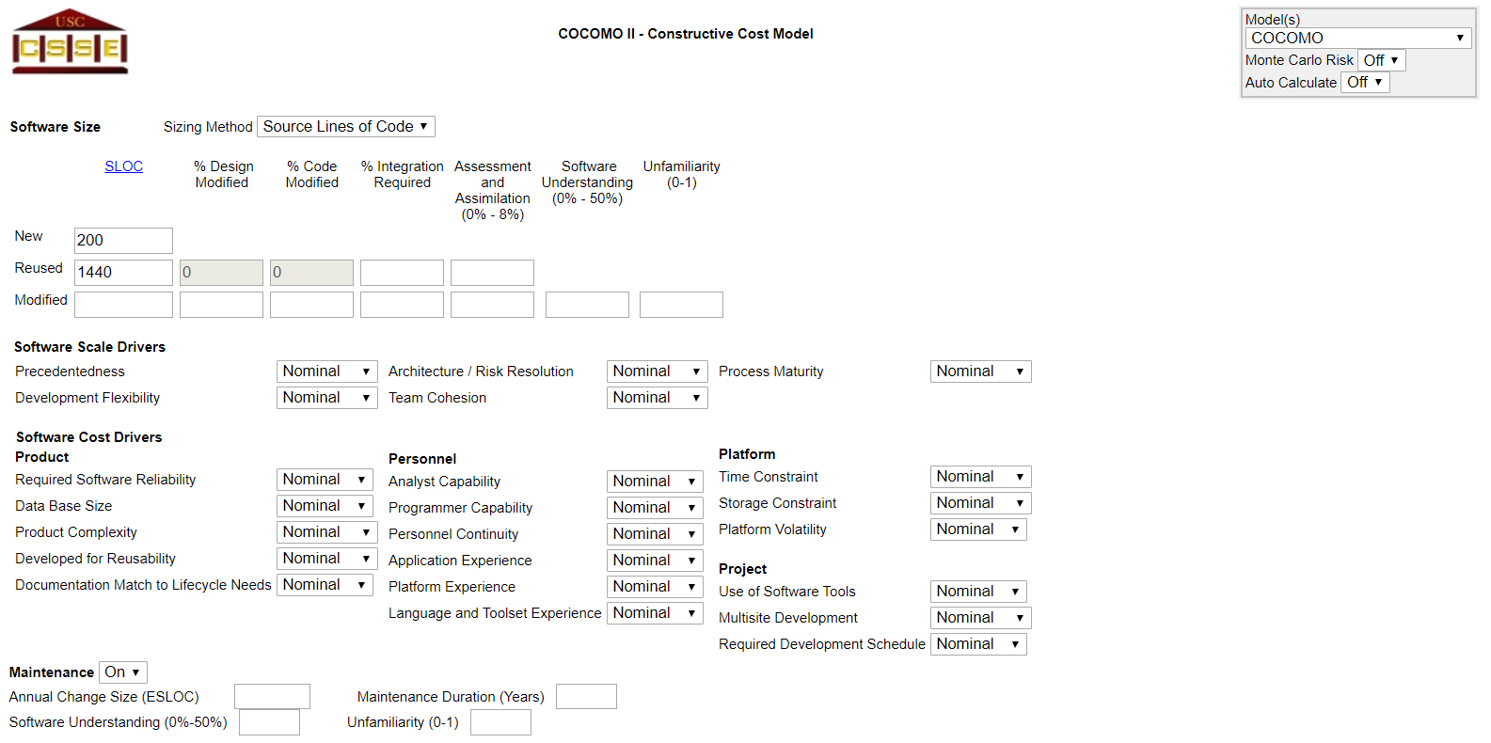

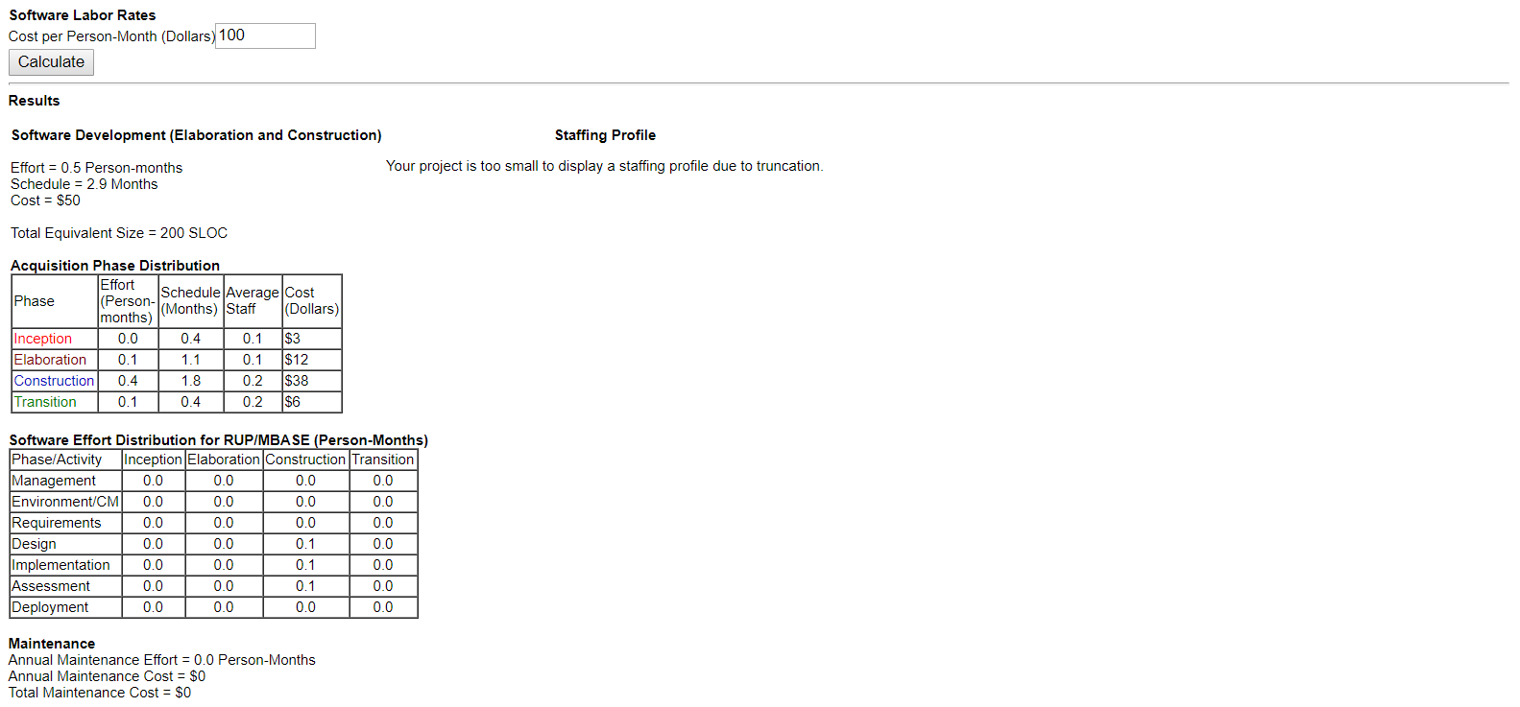

1. VVIA:
2. COCOMO COST COUNT:
3. Organic mode:

E=2.4(0.11)1.05 = 0.236 PM

D=2.5(0.236)0.38=1.44

Person Estimated, N = E/D = 0.16

1. Semi Detached:

E=3.0(0.11)­1.12=0.253PM

D=2.5(3.078)0.35=1.545

N=E/D=1.64

1. EMBEDDED MODE:

E=3.6(0.11)1.20=0.254

D=2.5(0.254)0.32=1.612

N=E/D=0.157

1. COCOMO Constructive Cost Model:

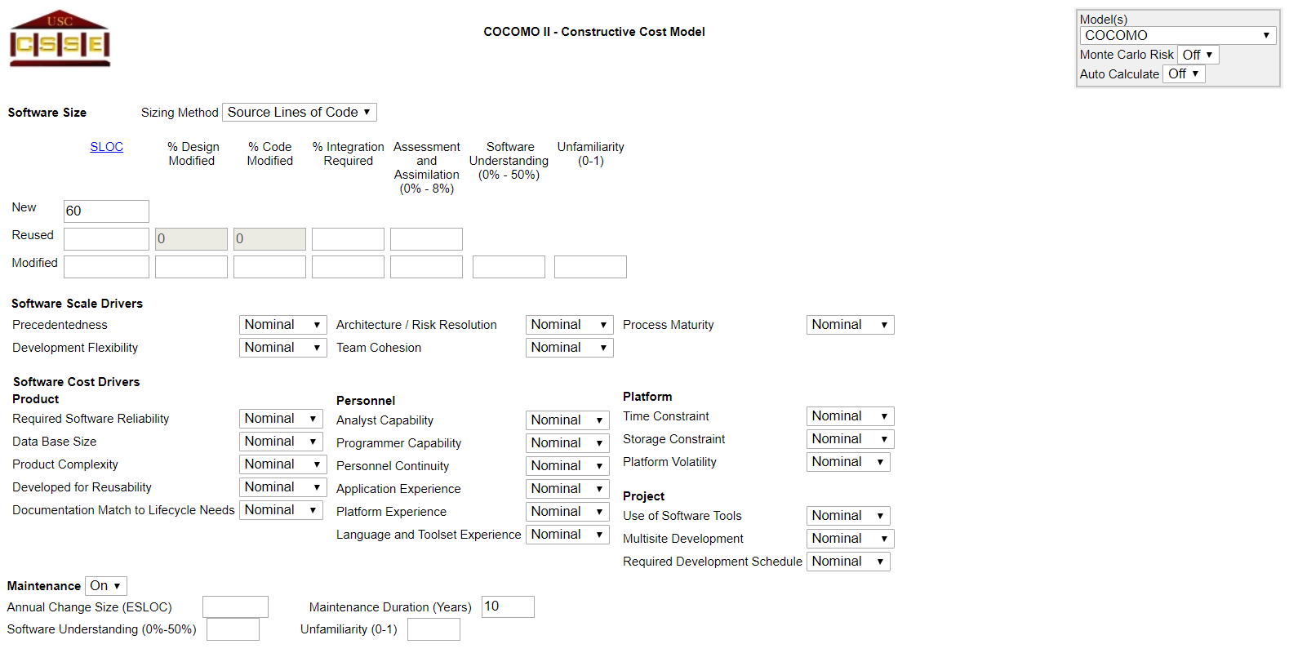

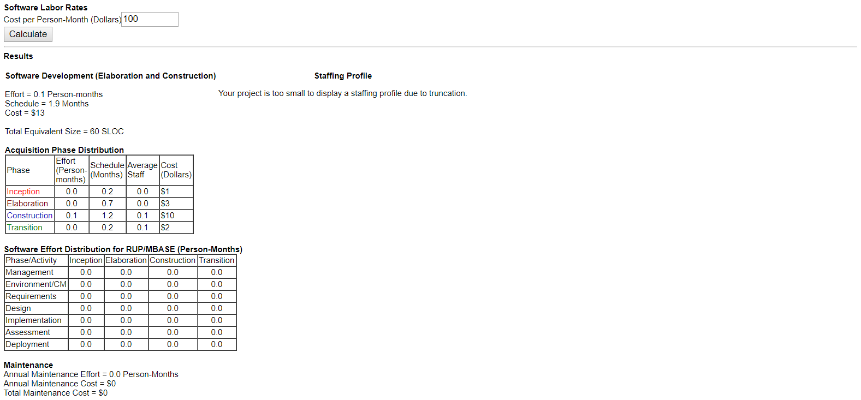

1. Linux:
2. COCOMO COST COUNT:
3. Organic mode:

E=2.4(13000)1.05 = 50101.619 PM

D=2.5(50101.619)0.38=152.71

Person Estimated, N = E/D = 32808

1. Semi Detached:

E=3.0(13000)­1.12=121545.1991PM

D=2.5(121545.1991)0.35=150.52

N=E/D=807.506

1. EMBEDDED MODE:

E=3.6(13000)1.20=31196.37

D=2.5(31196.37)0.32=143.12

N=E/D=2174.373

1. COCOMO Constructive Cost Model:

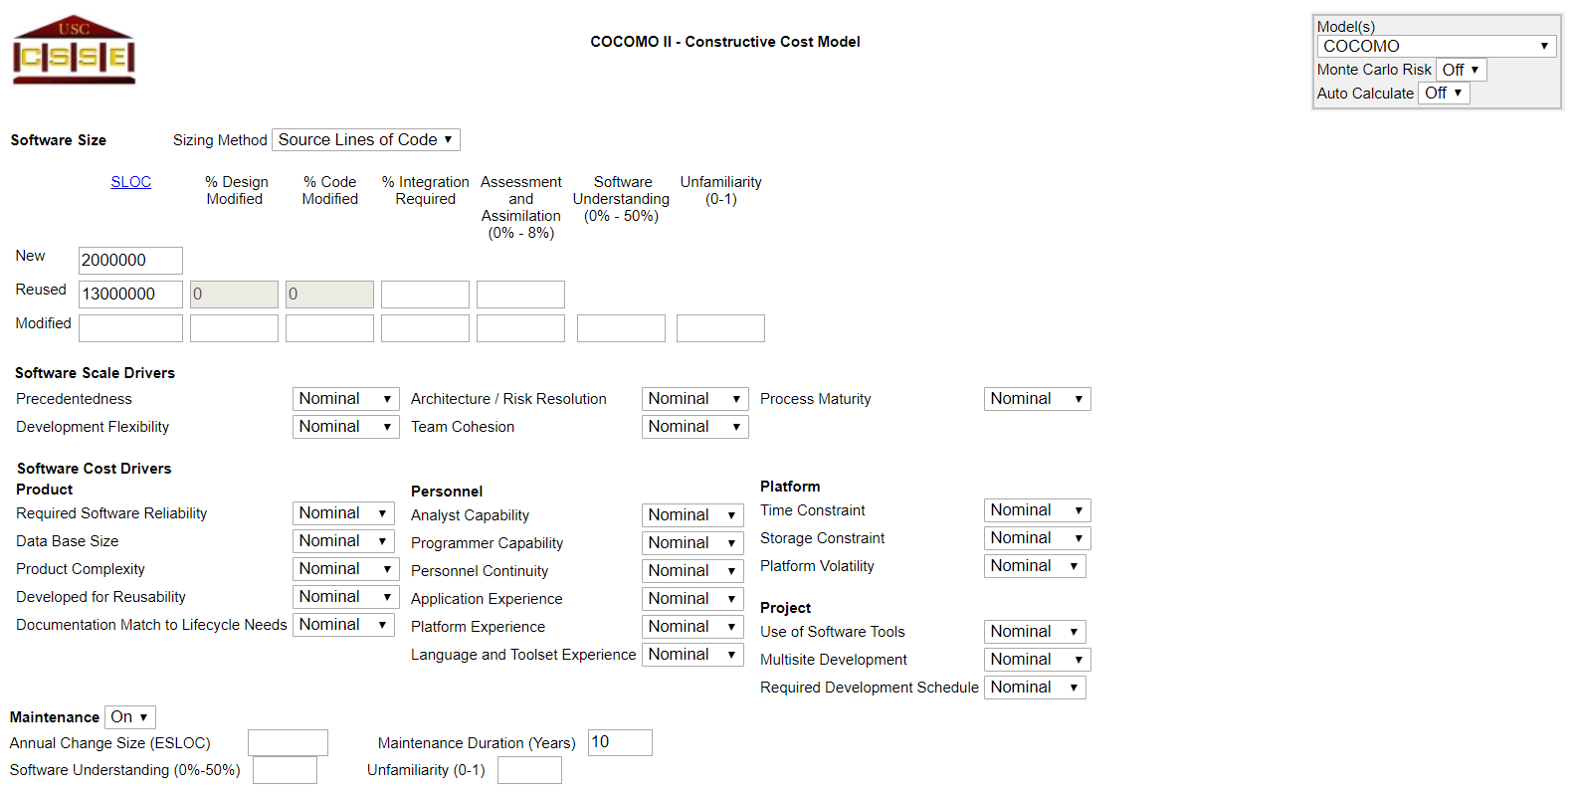

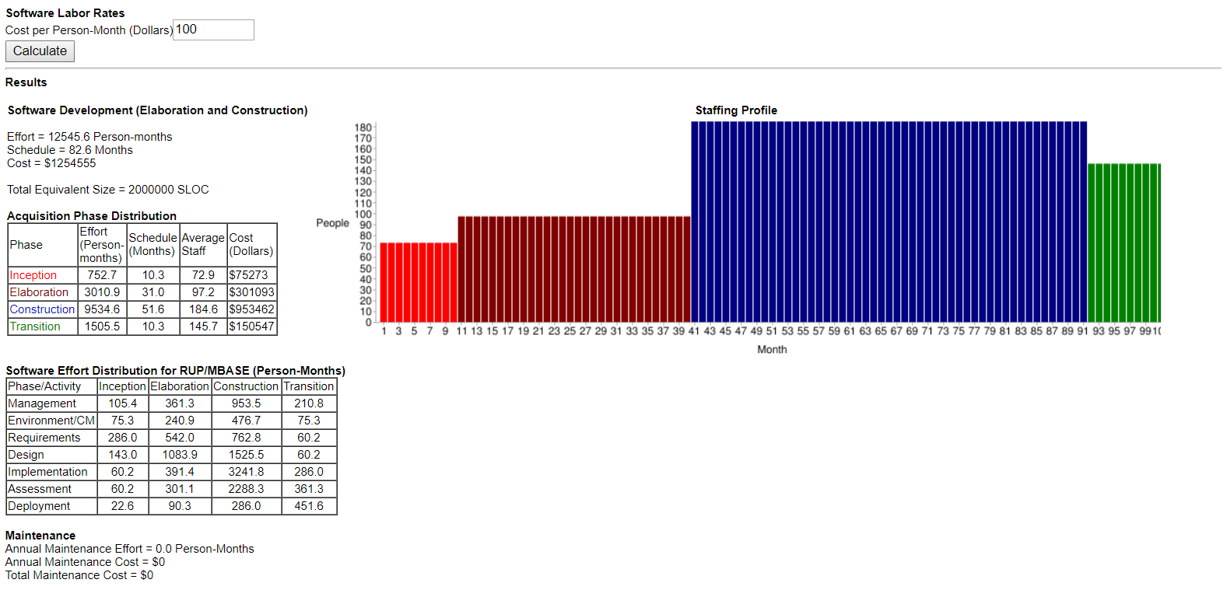

PERT DIAGRAM:

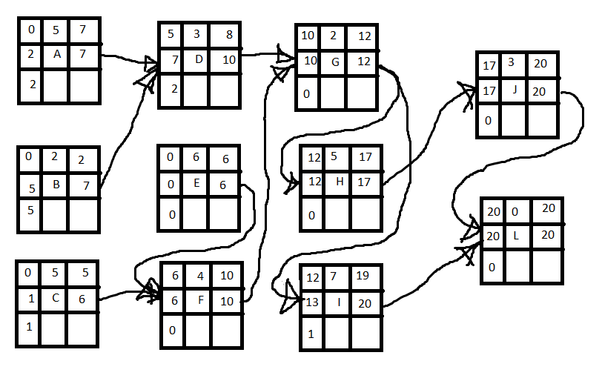

Therefore, the most critical tasks are: E, F, G, H, J